industry collaboration, to become successful professionals contributing for the betterment of society.
Mission Statement of the Department.
To nurture computer engineering professionals by offering Dynamic learning environment that encourages problem-solving using emerging technology, National Education Policy aligned evidence-based technical education, fostering ,innovation, research, and industry–institute collaboration & Holistic, ethical and sustainable development for lifelong success.

Session 2026-2027

Vision:Dream of where you want. | Mission: Means to achieve Vision

Program Educational Objectives of the program (PEO): (broad statements that describe the professional and career accomplishments)
PEO1 | Preparation | P: Preparation | Pep-CL abbreviation pronounce as Pep-si-lL easy to recall
PEO2 | Core Competence | E: Environment  (Learning Environment) | Pep-CL abbreviation pronounce as Pep-si-lL easy to recall
PEO3 | Breadth | P: Professionalism | Pep-CL abbreviation pronounce as Pep-si-lL easy to recall
PEO4 | Professionalism | C: Core Competence | Pep-CL abbreviation pronounce as Pep-si-lL easy to recall
PEO5 | Learning  Environment | L: Breadth (Learning in diverse areas) | Pep-CL abbreviation pronounce as Pep-si-lL easy to recall

Program Outcomes (PO): (statements that describe what a student should be able to do and know by the end of a program)
Keywords of POs:
Engineering knowledge,Problem analysis, Design/development of solutions,Conduct Investigations of Complex Problems, Engineering Tool Usage, The Engineer and The World,Ethics, Individual and Collaborative Team work,Communication, Project Management and Finance, Life-Long Learning

PSO Keywords: Cutting edge technologies, Research

“I am an engineer, and I know how to apply engineering knowledge to investigate, analyse and design solutions to complex problems using tools for entire world following all ethics in a collaborative way with proper management skills throughout my life.” to contribute to the development of cutting-edge technologies and Research.

Integrity: I will adhere to the Laboratory Code of Conduct and ethics in its entirety.

Name and Signature of Student and Date
(Signature and Date in Handwritten)

industry collaboration, to become successful professionals contributing for the betterment of society.
Mission Statement of the Department.
To nurture computer engineering professionals by offering Dynamic learning environment that encourages problem-solving using emerging technology, National Education Policy aligned evidence-based technical education, fostering ,innovation, research, and industry–institute collaboration & Holistic, ethical and sustainable development for lifelong success.

Session | 2026-27 (ODD) | Course Name | Web Technology Lab
Semester | 3 | Course Code | 23CT1301
Roll No | 49 | Name of Student | Devanshu Parshionikar

Practical Number | 4 - B
Course Outcome | - Understand various internet technologies.  - Design the web pages using HTML and CSS.  - Implement the XML technology to store the data.  - Develop the interactive web pages using JavaScript.
Aim | JavaScript — DOM Manipulation
Problem Definition | Build a To-Do List web app where users can add, delete, and mark tasks as complete, using vanilla JavaScript DOM methods only.
Theory  (100 words) | Document Object Model (DOM)  When the browser loads an HTML page, it builds an in-memory model of that page called the DOM.  The DOM represents the page as a tree of elements.  - HTML → creates the structure  - DOM → represents that structure in memory  - JavaScript → uses the DOM to read and change the page  What is DOM Manipulation?  DOM Manipulation means using JavaScript to:  - Find an element  - Read its value  - Change its content  - Create new elements  - Add elements to the page  - Remove elements from the page
industry collaboration, to become successful professionals contributing for the betterment of society.
Mission Statement of the Department.
To nurture computer engineering professionals by offering Dynamic learning environment that encourages problem-solving using emerging technology, National Education Policy aligned evidence-based technical education, fostering ,innovation, research, and industry–institute collaboration & Holistic, ethical and sustainable development for lifelong success.
 | ● Change its CSS classes
Procedure and Execution  (100 Words) | Step for Implementation:  Open a text editor (such as VS Code, Notepad, or Sublime Text). ● Create a new file named practical4a.html.  - Set up the standard HTML structure (<!DOCTYPE html>, <html>, <head>, <body>).  - Add an interactive element, such as an input field and a <button>, to trigger JavaScript execution.  - Define a JavaScript block inside <script> tags to read user input, run a basic greeting function, and dynamically update a heading or paragraph element on the page using the DOM.  - Save the file and open practical4b.html in a web browser.  - Click the button to observe dynamic content changes and inspect the browser console (F12) for output.
Procedure and Execution  (100 Words) | Code:  function addTask() {  let task = prompt(`Enter Task: `); let board = document.querySelector(".board"); return board.innerHTML = `<div class="task"> <h4 id="task_id">${task}</h4></div> <div> <button type="button" id="delete" onclick="delete()"> Delete </button></div>` + board.innerHTML;  }  function clearAll() { let board = document.querySelector(".board"); return board.innerHTML = ``; }
industry collaboration, to become successful professionals contributing for the betterment of society.
Mission Statement of the Department.
To nurture computer engineering professionals by offering Dynamic learning environment that encourages problem-solving using emerging technology, National Education Policy aligned evidence-based technical education, fostering ,innovation, research, and industry–institute collaboration & Holistic, ethical and sustainable development for lifelong success.
Output:
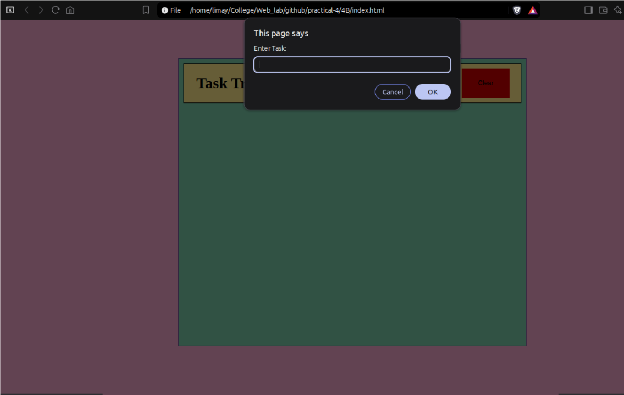
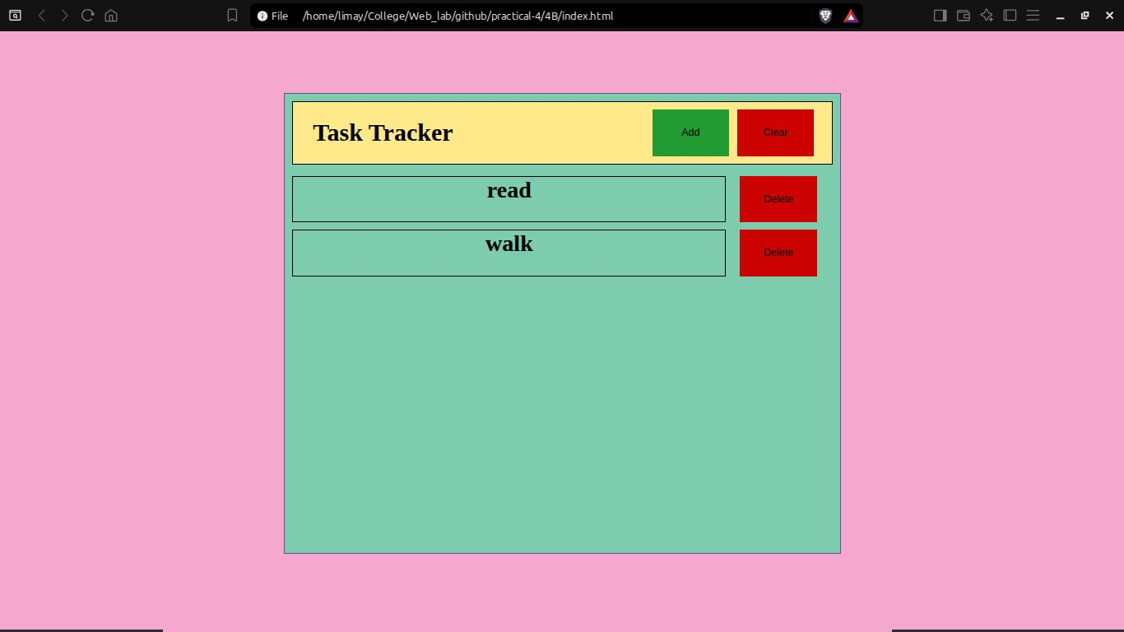
Output Analysis | Initially the task board was empty  - On clicking “Add” : The website prompts the user to type out a task and then creates a div and adds it to the main task board.  - On clicking “Clear” : The website clears the entire board of the list created.  - On clicking “Delete” : The website clears only the that specific task.

Vision Statement of the Department.
To be a preferred hub for nurturing computer engineering aspirants through innovative, ethical, value-based technical education, impactful research, and industry collaboration, to become successful professionals contributing for the betterment of society.
Mission Statement of the Department.
To nurture computer engineering professionals by offering Dynamic learning environment that encourages problem-solving using emerging technology, National Education Policy aligned evidence-based technical education, fostering ,innovation, research, and industry–institute collaboration & Holistic, ethical and sustainable development for lifelong success.
Link of student Github profile where lab assignment has been uploaded | https://github.com/DevanshuP03
Conclusion | Successfully studied the fundamentals of JavaScript and demonstrated dynamic client-side scripting, event handling, and DOM element manipulation in a web environment.
Plag Report (Similarity index < 12%) | 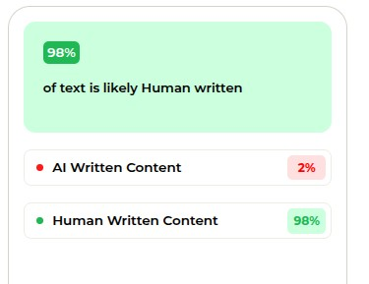
Date | 15/09/2026

